STEPS / ELEMENTS OF COMMUNICATION PROCESS
C. B. Mamoria has pointed out the parts of communication process by saying, “That communication process model is making up of seven steps or parts: a. the communication b. Encoding c. The message and the medium or channel, d. reception by the receiver e. decoding f. Action and g. feedback.”

The following diagram represents the communication process
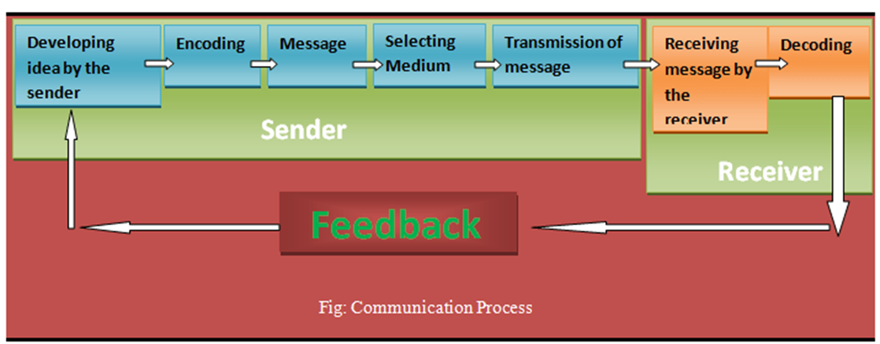
Thus, it is clear that communication process is the set of some sequential steps involved in transferring message as well as feedback. The process requires a sender who transmits message through a channel to the receiver. Then the receiver decodes the message and sends back some type of signal or feedback.
The communication process refers to the steps through which communication takes place between the sender and the receiver. This process starts with conceptualizing an idea or message by the sender and ends with the feedback from the receiver. In details, communication process consists of the following eight steps:
- Developing idea by the Sender: In the first step, the communicator develops or conceptualizes an idea to be sent. It is also known as the planning stage since in this stage the communicator plans the subject matter of communication.
- Encoding: Encoding means converting or translation the idea into a perceivable form that can be communicated to others.
- Developing the message: After encoding the sender gets a message that can be transmitted to the receiver. The message can be oral, written, symbolic or nonverbal. For example, when people talk, speech is the message; when people write a letter, the words and sentences are the message; when people cries, the crying is the message.
- Selecting the medium: Medium is the channel or means of transmitting the message to the receiver. Once the sender has encoded his into a message, the next step is to select a suitable medium for transmitting it to the receiver. The medium of communication can be speaking, writing, signaling, gesturing etc.
- Transmission of message: In this step, the sender actually transmits the message through chosen medium. In the communication cycle, the tasks of the sender end with the transmission of the message.
- Receiving the message by receiver: This stage simply involves the reception of sender’s message by the receiver. The message can be received in the form of hearing, seeing, feeling and so on.
- Decoding: Decoding is the receiver’s interpretation of the sender’s message. Here the receiver converts the message into thoughts and tries to analyze and understand it. Effective communication can occur only when both the sender and the receiver assign the same or similar meanings to the message.
- Feedback: The final step of communication process is feedback. Feedback means receiver’s response to sender’s message. It increases the effectiveness of communication. It ensures that the receiver has correctly understood the message. Feedback is the essence of two-way communication.

